**Functional Specification Document**

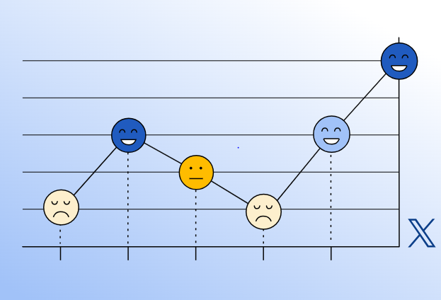

**Name**: Dawid Pionk

**Purpose Of Submission**: Specification Document Assignment for Sentiment analysis for Twitter

**Institution**: SETU, Carlow

**Date**: 25/10/2024

Table Of Contents

What is this application? 2

What Will it Do? 3

Who will use this program? 3

Context Diagram 3

Entities 4

Use Cases 4

Select Analysis Parameters Use Case 5

View Sentiment Use Case 5

Change Settings Use Case 5

View Tweets Parameters Use Case 6

Analyse topic Detailed Use Case 6

High Value Use Cases 6

High Risk Use Cases 7

Metrics 7

Inspiration 7

Social Searcher 7

Tweetbinder 8

References 9

# What is this application?

This application will be able to determine the sentiment of a certain topic/person/brand on twitter. It will let the user input a certain topic they want to search. Tweets relating to that topic would be extracted from twitter using web scraping. Those Tweets will be processed using machine learning techniques to determine the sentiment of those tweets. The data will be displayed for the user. The user will also have an option to view those tweets, and the sentiment identified with each.

# What Will it Do?

List of functionalities:

1. Analyze Sentiment (core)
2. Search by user, topic brand (core)
3. Display Sentiment statistics (core)
4. Settings (non-core)

# Who will use this program?

This program can be very useful in fields that require the need for judging the public's opinion on a certain topic. Also, people would be able to view specific tweets that were negative and see what kind of criticism they have. This could be used by marketing teams to see how their campaign is being received. Politicians can use it to view what type of policies are viewed most favorably. This tool could also be good for research purposes due to its function of being able to view sentiment in a certain period. Researchers could view what sort of opinion people had on a certain topic a decade ago.

# Context Diagram

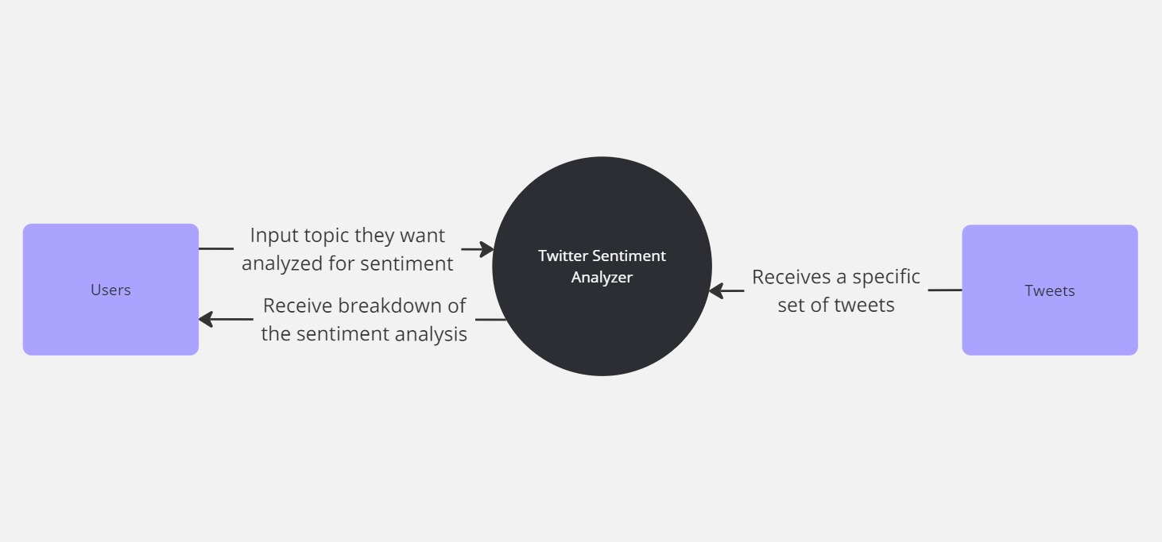Figure 1 – A context diagram of the twitter sentiment analysis project

## Entities

Users: this is the group of people that will be using this program, who will input topics and receive the sentiment of twitter towards that topic.

Twitter Sentiment Analyzer: This is the program itself

Tweets: This represents the twitter web client, from where the tweets will be extracted

# Use Cases

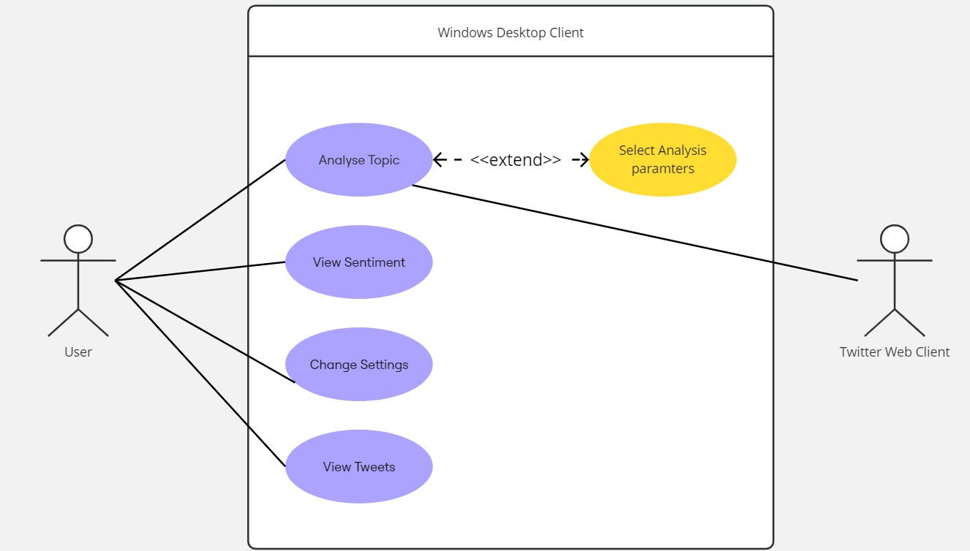Figure 2 – A use case diagram of the twitter sentiment analysis project

## Select Analysis Parameters Use Case

**Name:** Select Analysis

**Actors:** User

**Description:** This use case begins when the user clicks the filter button. The user selects which parameters should be used during the web scraping process, such as date posted, country of origin, etc. This use cases ends when the user applies their selected parameters.

## View Sentiment Use Case

**Name:** View Sentiment

**Actors:** User

**Description:** This use case begins when the user clicks the view sentiment button. The program processes the data from analyzing the topic. This use case ends when the sentiment analysis is displayed for the user.

## Change Settings Use Case

**Name:** Change Settings

**Actors:** User

**Description:** This user case begins when the user clicks the change settings button. The user selects what settings they want changed such as which graphs should be displayed or change font size. This use case ends when the user saves their changes.

## View Tweets Parameters Use Case

**Name:** View Tweets

**Actors:** User

**Description:** This use case begins when the user clicks the view tweets button. The user is shown the tweets processed during their search and the sentiment associated with each. This use case ends when the user leaves the view tweets section.

## Analyse topic Detailed Use Case

**Name:** Analyze topic

**Actors:** User, Twitter Web Client

**Description:** This use case begins when the user enters their topic into the search bar and clicks the analyze button. The program extracts tweets relating to the topic. Then it processes those tweets. This use case ends when the user is shown the breakdown of the sentiment analysis of their topic.

**Main Success Scenario:**

1. User enters their topic
2. User clicks analyze button
3. The program searches for tweets relating to that topic.
4. Using web scraping techniques tweets relating to that topic are extracted
5. Those tweets are analyzed using machine learning techniques
6. Those tweets are classified
7. Charts and graphs are created using the data
8. Those charts and graphs are displayed for the user

**Alternatives:**

2a. The search is empty:

1. The program doesn’t go ahead

2. An error message is displayed for the user.

3a. The program can’t identify any tweets relating to the selected topic.

1. The program doesn’t go ahead

2. An error message is displayed for the user.

3b. Twitter blocked access to the IP of the user due to too many previous searches.

1. The program doesn’t go ahead

2. An error message is displayed for the user.

## High Value Use Cases

* View Sentiment
* Analyse Topic

## High Risk Use Cases

* View Sentiment
* Analyse Topic

# Metrics

How will the success of the project be measured:

* Create an AI that will be able to correctly analyze the sentiment of a tweet
* Extract 1000 tweets and analyze them within 10 seconds
* Display the data in easy-to-understand graphs and charts

# Inspiration

## Social Searcher

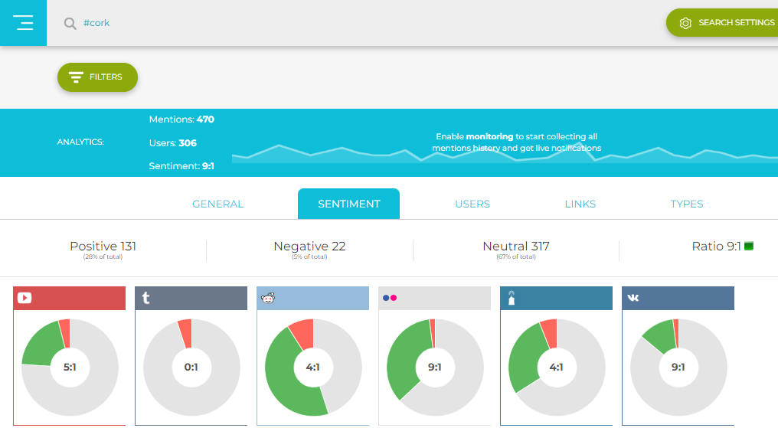Figure 3 – A screenshot from social searcher of sentiment analysis for #cork [2]

Social searcher is a web-based sentiment analysis tool. The user enters their topic, and the program scours the web looking for related posts. It analyses the posts and categorizes them. It displays the sentiment of that topic. The user can view the posts and their categorization. There are several graphs and charts that can be viewed with breakdown from each platform.

Social Searcher offers a lot of similar functionalities to what my program would offer but there are some major differences. This program focuses on several social media platforms while mine will focus solely on twitter. It only searches for recent mentions while the proposed program will allow the user to narrow down their search. To access the individual tweets the user needs to purchase premium, while in my program it will be free of charge. The number of mentions is limited to a maximum of about 500, while on my app that would be higher. Also, my program will offer a larger variety of visualization of data.

## Tweetbinder

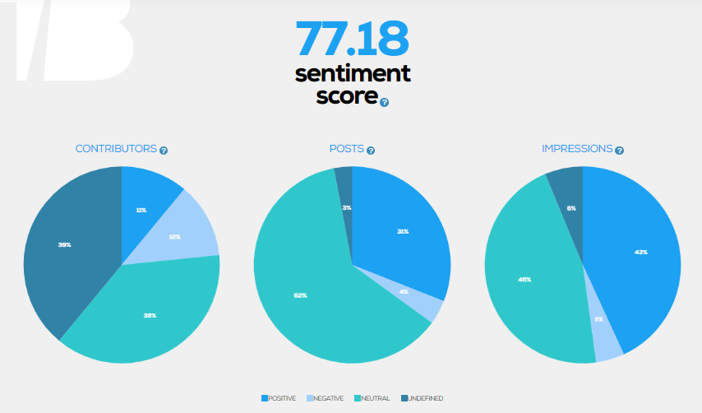Figure 4 – A pie chart from Tweetbinder of sentiment analysis of #cork

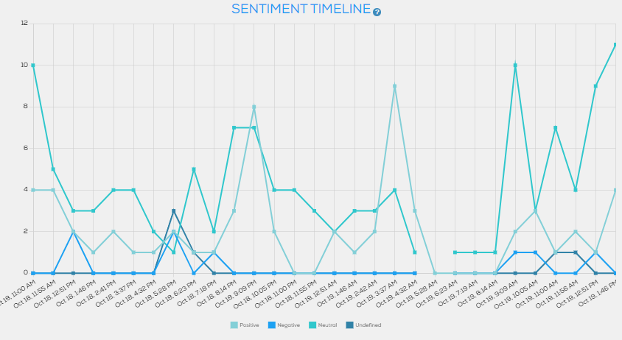Figure 5 - A graph of sentiment over time from Tweetbinder of #cork [3]

Tweetbinder is a web base sentiment analyzing tool. Similarly to my program, it solely focuses on sentiment analysis on twitter. The user enters a hashtag or an account they want analyzed and a report on that subject is generated. The user can then adjust the dates, view the sentiment, the economic value of a hashtag or account, etc.

Tweetbinder offers a lot of similar functionalities to what my program would offer but there are some major differences. The free limit on analyzed tweets is 200, which would be lower than what I intend to set it at. The user can’t access a lot of the features such as filtering dates without paying for an expensive premium account, which wouldn’t be an issue on my app. The data is displayed in a confusing manner, the user is shown a lot of data at once which might confuse them. In my program the user would be shown the simple breakdown of the sentiment and then they will have an option to view more details if they choose so.

# References

[1] Hodgson, J. (2024). Harnessing X (Twitter) sentiment analysis for strategic business insights. [online] Sprout Social. Available at: https://sproutsocial.com/insights/twitter-sentiment-analysis/ [Accessed 23 Oct. 2024].

[2] Social Searcher (2011). Social Searcher - Free Social Media Search Engine. [online] Social-searcher.com. Available at: https://www.social-searcher.com/.

[3] Tweet Binder. (n.d.). Twitter Hashtag tracking tool - Tweet Binder, the real Twitter impact. [online] Available at: https://www.tweetbinder.com/.